**TASK – 1**

* **APPLICATION NAME – GOOGLE MEET**

*I'll select Google Meet as the application for analysis. It’s widely used for virtual meetings but has room for improvement in user experience and functionality*

**THE STEPS OF DESIGN THINKING**

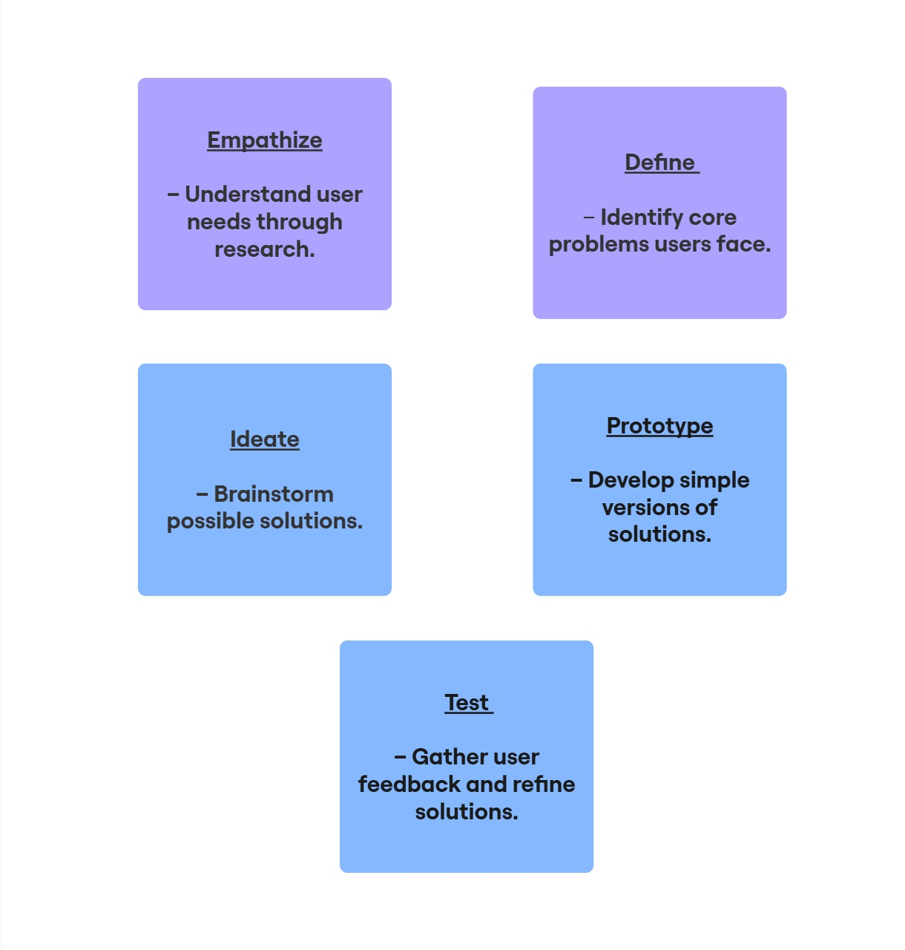

* ***Areas for Improvement in GOGGLE MEET***

**Based on user feedback and common complaints, here are some areas for improvement in Google Meet:**

* ***Better Noise Cancellation:*** **Background noise filtering could be improved for a smoother experience.**
* **I*ntegrated Whiteboard & Annotations****:* **More interactive collaboration tools within the app.**
* ***More Customization in Layouts****:* **Users want flexibility in how they view participants.**
* ***Offline Mode:*** **Ability to record and access meetings offline**.
* ***Seamless Multi-Device Sync:*** **Smooth transition between mobile and desktop devices.**

**CREATE A GAP ANALYSIS**

* ***ITS IDENTIFIES THE DIFFRENCE B/W THE CURRENT STATE AND THE IDEAL STATE OF THE PRODUCT***

|  |  |  |  |
| --- | --- | --- | --- |
| **FEATURE** | **CUREENT STATE** | **DESIRED STATE** | **GAP IDENTIFIED** |
| **NOISE CANCELLATION** | ***Basic AI-based noise suppression*** | ***Advanced AI- powered background noise elimination*** | ***Higher quality audio, even in noisy environments*** |
| **WHITEBOARD & ANNOTIONS** | ***Limited to external tools*** | ***Built – in interactive whiteboard & live annotations*** | ***More seamless brainstorming and collaboration*** |
| **LAYOUT CUSTOMIZATION** | ***Few preset layouts*** | ***Fully customization layout options*** | ***Users can arrange screens as per their preference*** |
| **OFFINE MODE** | ***Not available*** | ***Ability record and access meeting offline*** | ***Accessibility in low- connectivity areas*** |